**Story 1.**We have given datasets about health and fitness, below is the visualization created from two datasets “HNP_ StatsData.csv” and “HNP_StatsCountry.csv” from union of these two datasets I have shown the income group country wise and their respective leading category along with the balance of payments. We have completed this visualization using symbol maps visualization as you can see

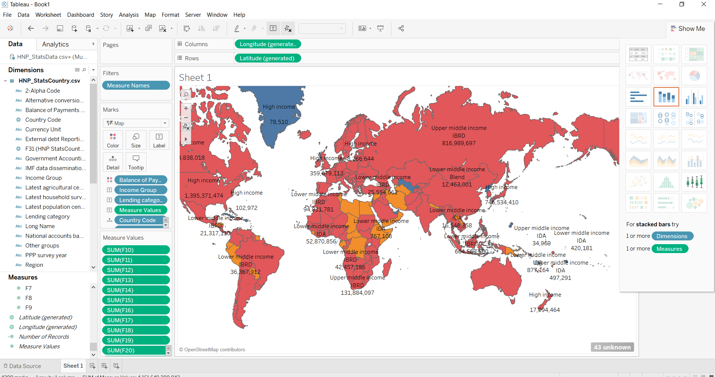

**Story 2.** We have given datasets about health and fitness, below is the visualization created from two datasets “HNP_ StatsFootNote.csv” and “HNP_StatsCountry-Series.csv” from union of these two datasets I have created the visualization showing the country code, country series description and footnote description where size and colour according to the number of records and number of measures. We have completed this visualization using squared pie charts visualization as you can see

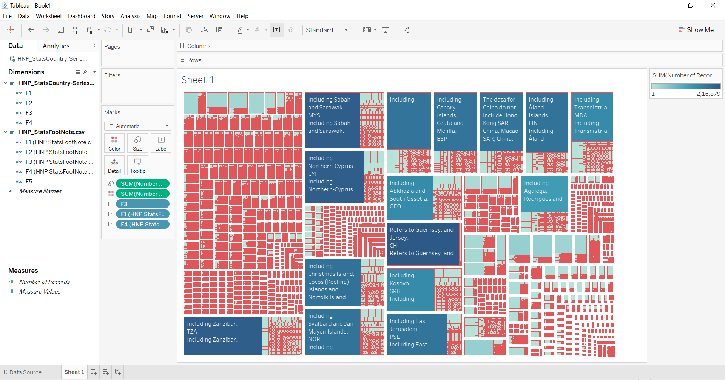

**Story 3.** **.** We have given datasets about health and fitness, below is the visualization created from two datasets “HNP_ StatsFootNote.csv” and “HNP_StatsCountry.csv” from union of these two datasets I have created the plot of latest trade data vs latest industrial data . We have completed this visualization using stacked bars visualization as you can see

